QUESTION ONE: Vulnerabilities scanning:
1. Install Nessus on your system.
2. Perform a vulnerability scan on the Metasploitable machine using Nessus.
Take screenshots of the identified vulnerabilities.
Provide a detailed description of the scanning process, including any
configurations or settings used. Submit the screenshots along with the
description.
CONFIGURATION OF NESSUS IN KALI LINUX:
- Download Nessus, Debian Based in the official Nessus Website: https://www.tenable.com/downloads/nessus?loginAttempted=true
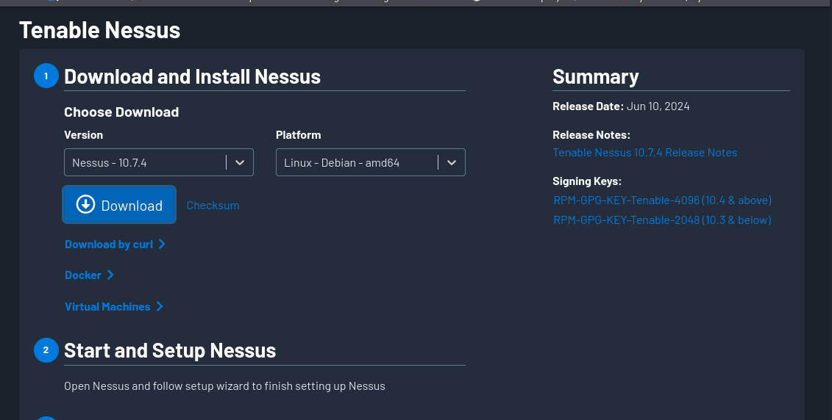
- Install Nessus in the Terminal. You navigate to the folder where your downloaded nessus is located the run this command: sudo dpkg -i Nessus-<Version Number>-debian10_amd64.deb: in the version number you insert the version number of your downloaded nessus e.g: sudo dpkg -i Nessus-10.7.4-debian10_amd64.deb

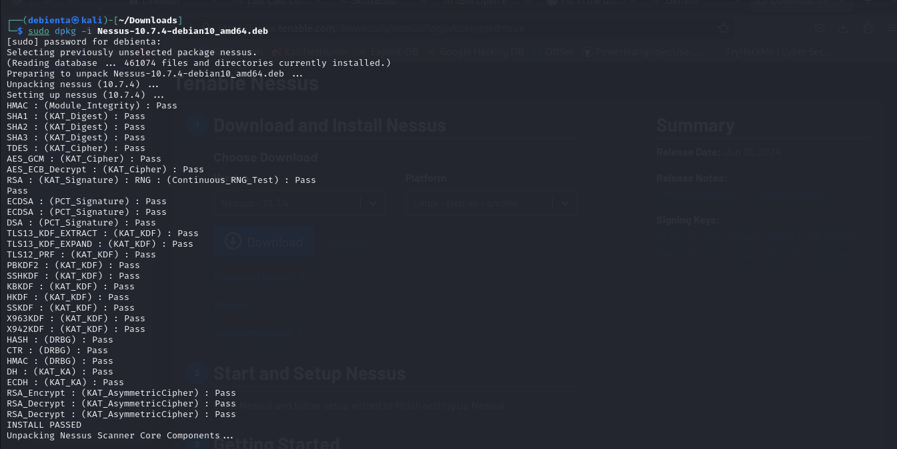

- To start nessus open terminal and type this command: sudo systemctl start nessusd

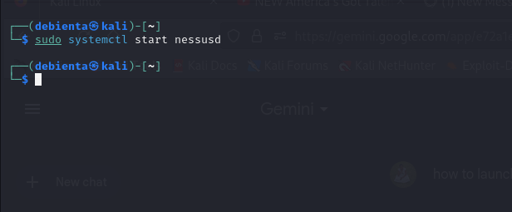
- To access a locally installed Tenable Nessus instance, go to https://parrot:8834/ When you access Tenable Nessus in a browser, a warning appears to regard a connection privacy warning appears as shown below.
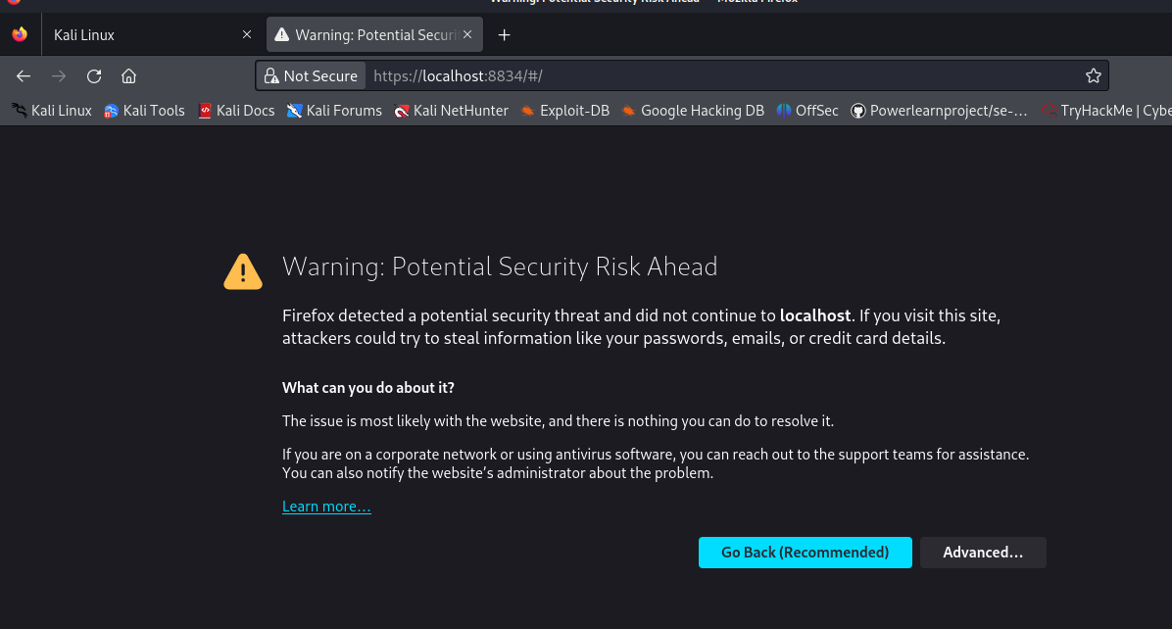
- Click on Advanced then Accept Risk and Continue.
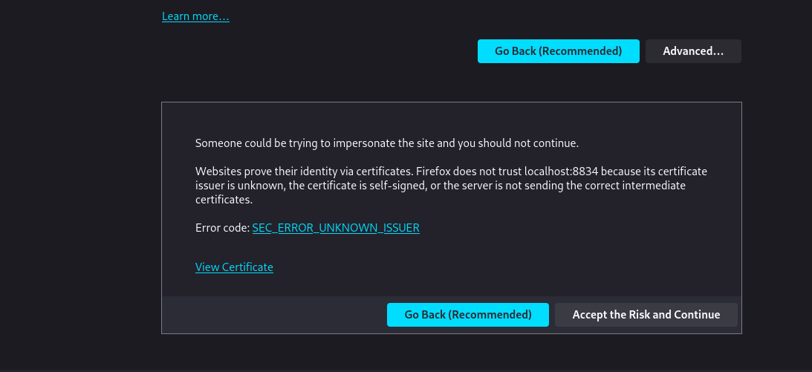
- The nessus is launched as shown below: click on Continue
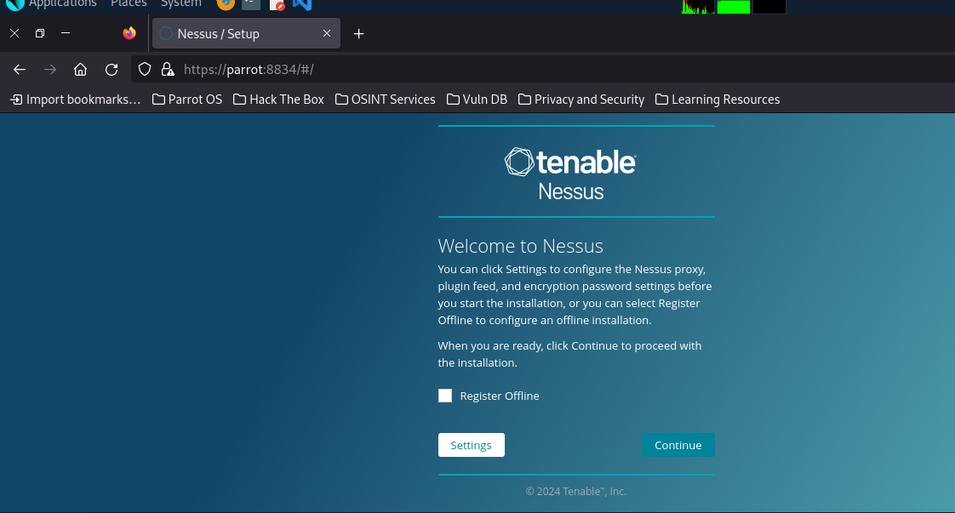
- Select on Register for Nessus Essential as shown below: and click continue


- Register to get an activation code using your names and email but if you already have a code click on skip to continue.
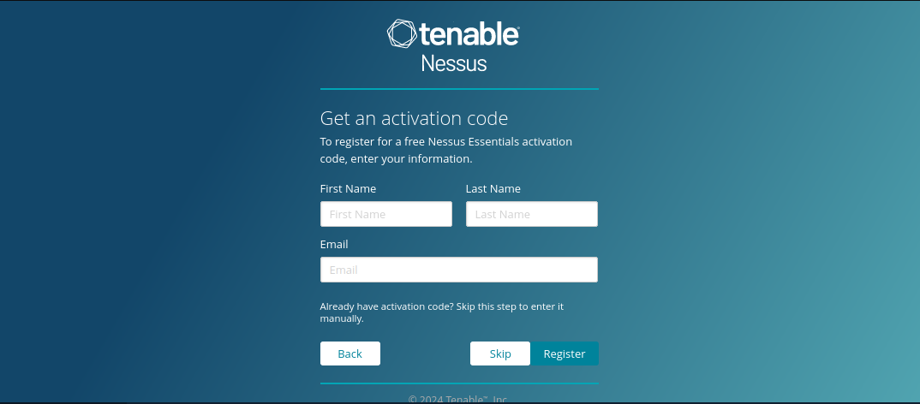
- After registering enter your activation code on the next prompt and click on continue.
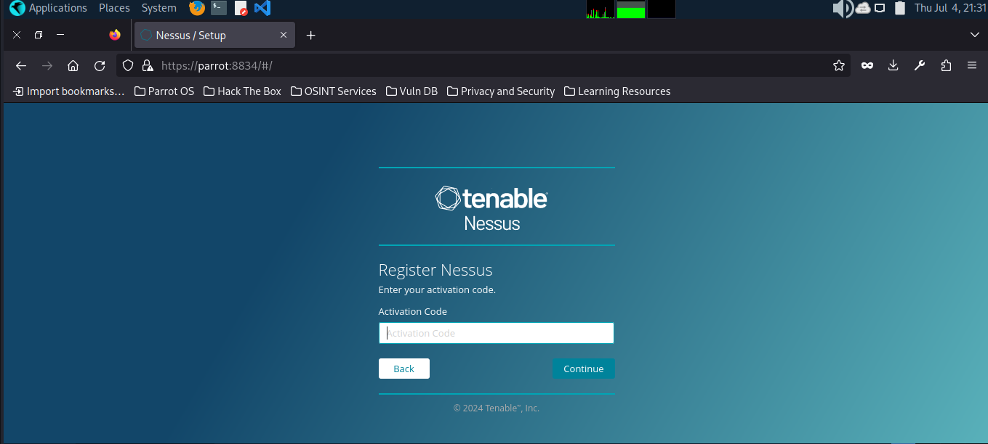
- Create your nessus account by entering your username and password and click on Submit.
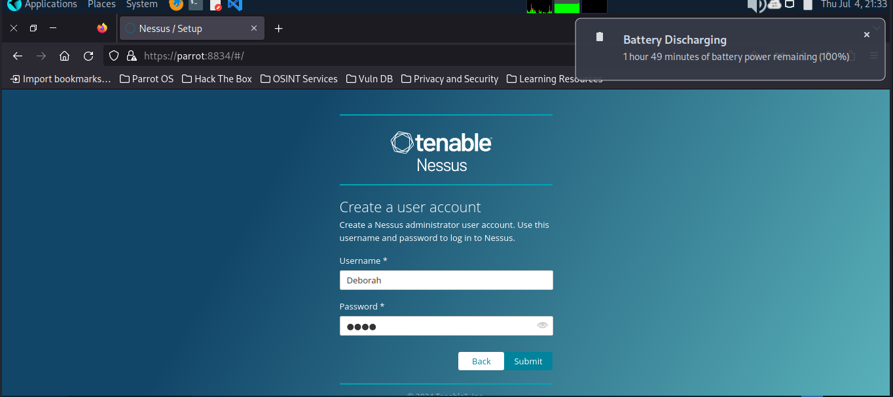
- Wait while nessus downloads necessary plugins
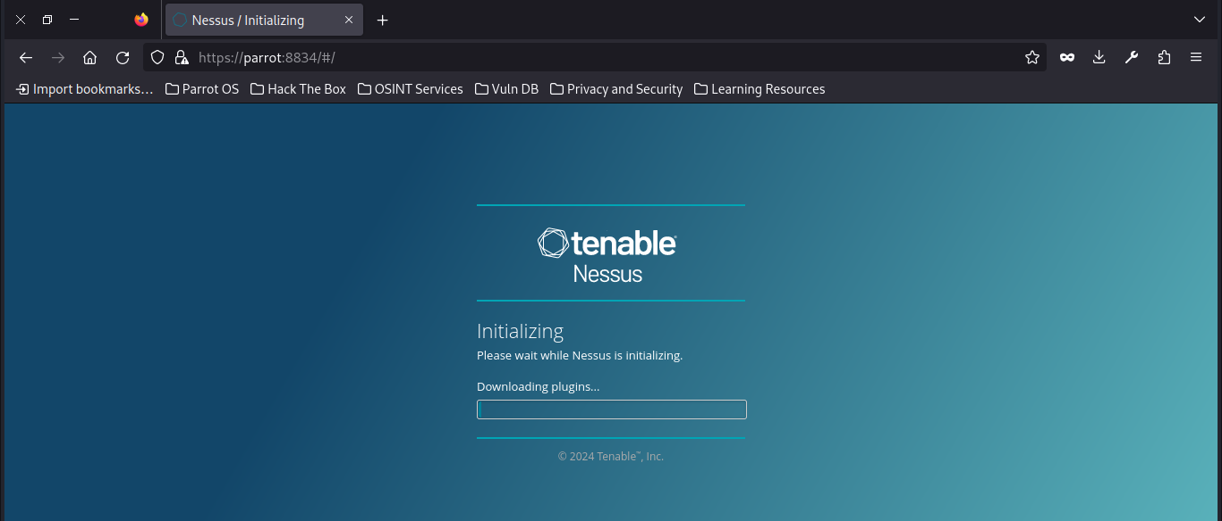
- After all plugins are installed, you are brought to this page where you can carry your activities
